Cabin Fever Quilters’ Guild
Membership Form
STATUS: New Member _____ Renewing Member _____ Address or other Change _____
NAME: ____________________________________________________________________________________
MAILING ADDRESS: __________________________________________________________________________
CITY: __________________________________ STATE: __________________ ZIP: _________________
HOME PHONE: ______________________________ CELL PHONE: ___________________________________
E-MAIL ADDRESS: ___________________________________________________________________________
BIRTHDAY: Month _____________________________ Day _________
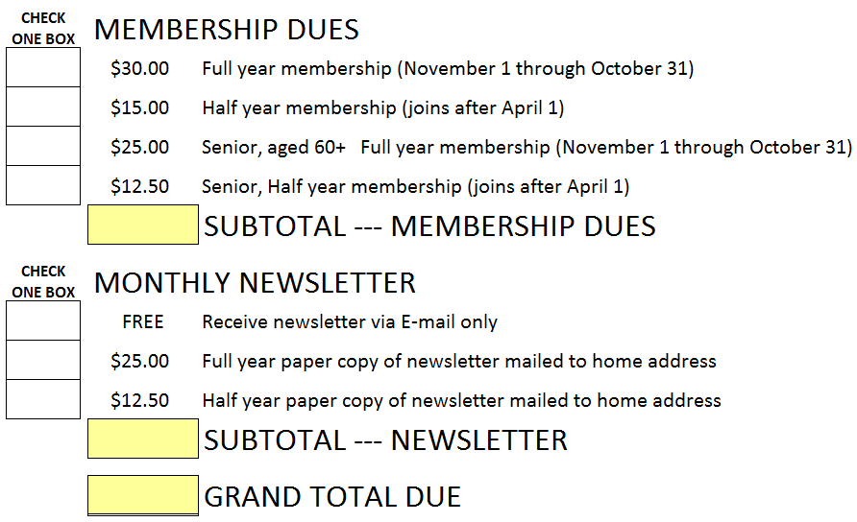
- Member dues must be received by October 31st to ensure inclusion in the annual guild directory.
- Make checks payable to CFQG. Complete the form and bring it to the next guild meeting, or mail form and payment to:
CFQG Membership
P.O. Box 83608
Fairbanks, AK 99708

NEW MEMBERS, PLEASE COMPLETE PAGE TWO

Membership Committee Use Only:
Amount Paid: $____________________________ Date Received: ____________________________________
Type of Payment: Cash or Check Number: _______________________________________________
Welcome to the Cabin Fever Quilters’ Guild
Please take a few minutes to tell us about yourself. How long have you lived in Alaska? Where are you from originally? How did you learn about our guild? What are your hobbies and interests? What are your quilting experiences? Tell us a little about your family and anything else that will help us to know you better.

